# Teacher Retention Roadmap

# This Project is funded in part by the Georgia Professional Standards Commission from federal Transition to Teaching funds awarded by the U.S. Department of Education.

It is estimated that the nation’s 50 largest school districts lose approximately 10,000 of their most effective teachers every year. If as a principal, you’ve ever lost a great teacher, you know how difficult it can be to replace that teacher with someone of equal quality. In fact, studies have shown that it can take up to 11 new hires to do so effectively. For this reason, it is critically important that schools do a better job of keeping their best teachers. Follow the steps below to ensure that you are doing everything in your power to retain your most effective educators.

Step 1: Understand Why Top Teachers Leave Their Schools

Before you can begin to retain your teachers, it’s important to understand the real causes of what makes teachers leave. TNTP launched the *Irreplaceables* study, a 4-district study encompassing 90,000 teachers, 2,100 schools and 1.4 million students aiming to explore why it is that great teachers leave their schools at such startling rates. Contrary to what some principals may believe, the attrition of Irreplaceable teachers can be easily prevented. There are simple, low-cost steps principals can take to double the time great teachers plan to remain at their schools. Read through this study to find out why teachers leave and what you can do to keep them.



**Resources:**

*The Irreplaceables: Understanding the Real Retention Crisis in America’s Urban Schools*

* [Full Report](http://tntp.org/assets/documents/TNTP_Irreplaceables_2012.pdf)
* [Executive Summary](http://tntp.org/assets/documents/TNTP_Irreplaceables_ExecSum_2012.pdf)
* [Principal Tips: 5 Ways Principals Can Keep More Irreplaceable Teachers](http://tntp.org/assets/documents/TNTP_Irreplaceables_PrincipalGuide_Web.pdf)

Step 2: Accurately Identify Your Highest Performing Teachers

*The Irreplaceables* shows that top and bottom performing teachers are retained at strikingly similar rates. Ideally, high performing teachers would be kept at much higher rates than low performing teachers, who should be counseled out of the profession if they cannot rapidly improve. Part of the problem is that many principals have not done a great job of differentiating between their highest and lowest performers. Go through your roster of teachers and identify your best by looking at how much their students learn, grown, and achieve. Those that consistently leverage student performance are your best teachers. Those that do not, aren’t.

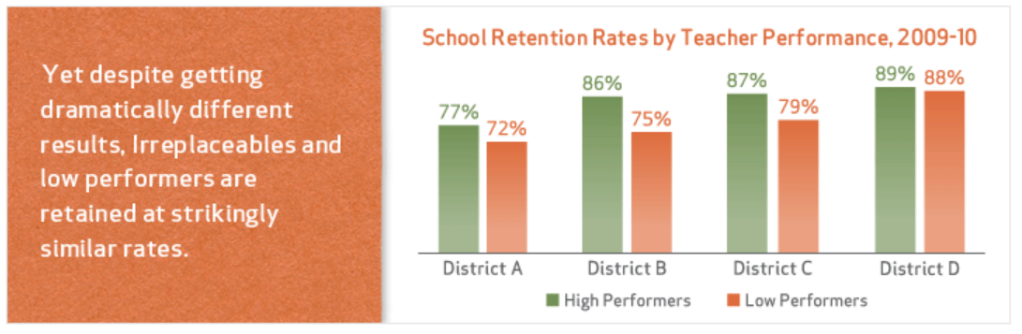

Step 3: Encourage Your Best Teachers to Stay

Once you’ve identified your best teachers, make sure that—at a minimum—you take the following actions with your most effective teachers:

1. Tell them that they are high performing.
2. Inform them that you want them back next year.
3. Ask them what it would take to ensure that they return.



Step 4: Create a Retention Plan

Use the following resources and retention strategies to create effective retention plans targeted to your best teachers.



*Above:* Teachers ranked eight retention strategies from 1 (unimportant) to 5 (very important)

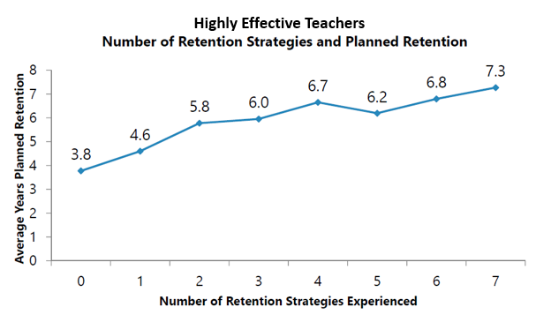

*Above:* Those effective teachers who experienced more retention strategies plan to stay at their schools longer.

**Resources:**

  